Dasar Teori

1. SMS over SIP

Definition:

* Circuit Switched Short Message Mobile Originated (CSM-MO)

SMS yang mendukung submision dari sms dari stasiun mobile(MS) yang switch rangkangaian yang dipasang ke SMS-GW,

* Circuit Switched Short Message Mobile Terminated (CSM-MT)

Jasa SMS yang mendukung penyampaian pesan singkat dari SMS-GW ke stasiun yang mobile yang CS-*attached.*

* IMS Short Message Mobile Originated (ISM-MO)

Jasa sms dengan IMS yang mendukung *submision*  dari pesan singkat ke SMS-GW dari stasiun mobile yang IMS- *attached*

* IMS Short Message Mobile Terminated (ISM-MT)
* Jasa sms dengan IMS yang mendukung  pengiriman pesan singkat ke SMS-GW dari stasiun mobile yang IMS- *attached*
* SMS

Pesan singkat yang didefinisikan dengan [C.S0015] yang disampaikan dengan IMS/ 1x CS

* SMS-GW

Suatu hal yang dapat menyimpan dan mengirim SMS ke dan dari SME yang dapat diregistrasikan dari IMS/1xCS

* Arsitektur Referensi dan *interface*
* SMS over IMS Architecture

Arsitektur akhir ke akhir menggunakan modul yang disegment. Cotoh gambarnya:

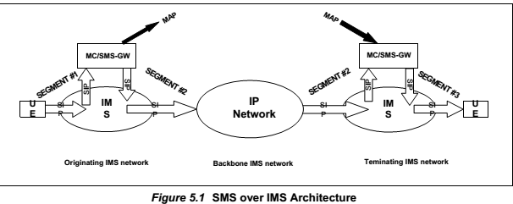

Setiap segmen pada gambar diats merupakan segmen IMS,tapi secara umum,dapat mengoperasikan transportasi non-IMS ke segment apapun,untuk model ini segment yang awal digunakan untuk pengirim pesan SMS untuk mengirim sms ke MC/SMS-GW untuk mengirimkan sms itu ke MC/SMS-GW yang sedang dihilangkan.

Ada dua arsitektur MC dan SMS-GW yang mendukung pengiriman SMS pake IMS,satu arsitektur yang memisahkan Fungsi SMS-GW dengan MC dana mengintegrasikan ke entities SMS-GW dan MC secara terpisah,kedua arsitektur yang menggabungkan MC dan SMS-GW dalam satu benda.

Arsitektur kedua dapat dilihat dallam gambar dibawah ini:

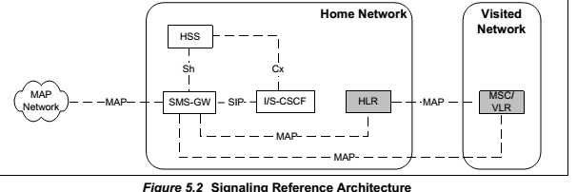

* Functionas entities

1. Short Message Service Gateway (SMS-GW)

SMS-GW yang menyediakan jasa menyimpan dan mengirim pesan singkan untuk/dari SME yang dapat didaftarkan untuk IMS/1xCS

Fungsi utama dari SMS-GW adalah

* to connect to the HLR using established MAP protocols and to acquire the UE’s MSID and the SMS address;
* to connect to MSC/VLR using established MAP protocols and to receive Short Message and forward Short Message to MSC/VLR;
* to act as an Application Server towards the IMS core;
* Interface

1. SMS-GW/S-CSCF(ISC)

SMS-GW yang dapat berkomunikasi dengan interface sinyal SIP ISC

1. dSMS-GW / HSS (Sh)

*interface* SMS-GW ke HSS dengan *interface* [MMD Part-10] Sh, untuk mendapatkan status registrasi subscriber dan nama S-CSCF

1. SMS-GW / HLR (MAP)

Berfungsi sebgai MC,SMS-GW *interface* untuk 1XCS HLR dengan menggunakan MAP untuk mendapatkan alamat SMS subscriber

1. SMS-GW / MSC (MAP)

Berfungsi sebgai MC,SMS-GW *interface* untuk 1XCS MSC dengan menggunakan MAP untuk mendapatkan pesan singkatdari MSC/ mengrimkan pesan singkat ke MSC.

* *Signaling Flows for SMS*
* Prosedur Registration
* SMS-GW IMS 3rdParty Registration – Success Scenario

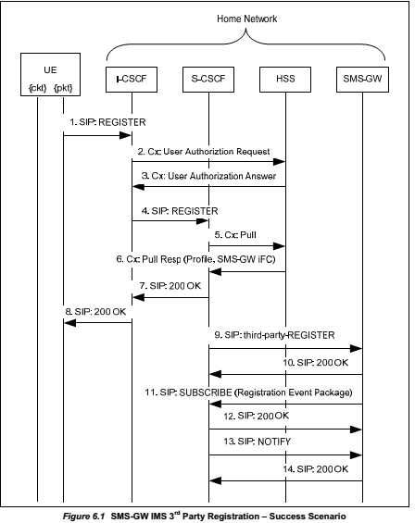

1. The UE sends a SIP REGISTER to the I-CSCF via the P-CSCF (not shown for brevity).
2. The I-CSCF queries the HSS to get the address of the S-CSCF.
3. The HSS returns the address of the S-CSCF for this user.
4. asas

* Domain Availability Notification

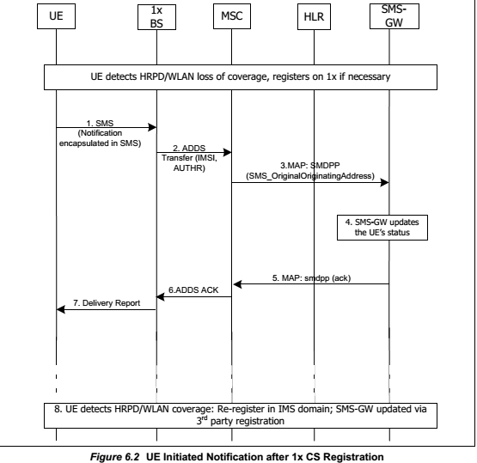

1. On detecting HRPD/WLAN loss of coverage, the UE registers on 1x CS if necessary. The UE encapsulates the notification updatein an SMS message addressed to the SMS-GW (i.e., address to E.164 number associated with the SMS-GW PSI, which is provisioned at the UE).
2. An ADDS Transfer message is sent from the 1x BS to the Visited MSC.
3. The Visited MSC forwards the SMS message to the SMS-GW.

* SMS Delivery Procedures

This section assumes that the terminating SMS-GW receives an SMS message from an originating SMS-GW via MAP. However it is not precluded that the terminating SMS-GW can receive an SMS message from an originating SMS-GW via SIP.

* Initial IMS Delivery Attempt: Success Scenario

Xs

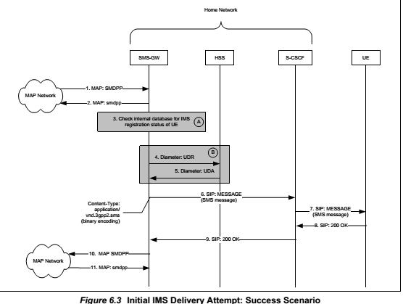

1. The SMS-GW for the UE receives a MAP SMDPP message for the UE from an originating SMS-GW. The originating SMS-GW is not shown for brevity.
2. The SMS-GW responds by sending a MAP smdpp message back to the originating SMS-GW.
3. Option A: If the SMS-GW receives IMS 3rdparty registrations or Registration Event notifications from the S-CSCF, then it checks its internal data base and determines that the UE is IMS registered.

* Initial IMS Delivery Attempt, Not IMS Registered: 1x CS Delivery Success

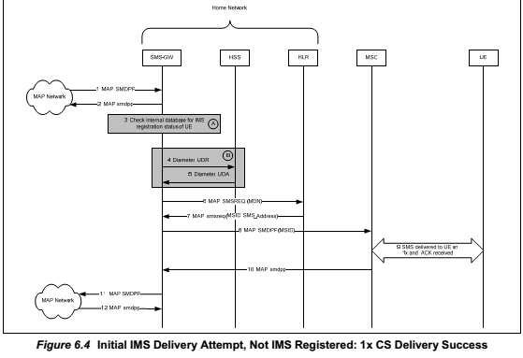

1. The SMS-GW for the UE receives a MAP SMDPP message for the UE from an originating SMS-GW. The originating SMS-GW is not shown for brevity.
2. The SMS-GW responds by sending a MAP smdpp message back to the sender of the MAP SMDPP message.
3. Option A: If the SMS-GW receives IMS 3rdparty registrations or Registration Event notifications from the S-CSCF, then it checks its internal data base and determines that the UE is not IMS registered.
4. sas

* Initial IMS Delivery Attempt, Not IMS Registered, Not 1x CS Registered, UE Availability Notification through HSS or 3rdParty Registration: IMS Delivery Success

Figure below illustrates a signaling flow for the scenario where a terminal that is initially neither

IMS nor 1x CS registered. SMS-GW subscribesto HSS for notification and when the UE

registers over IMS, the SMS message issuccessfully delivered over IMS.

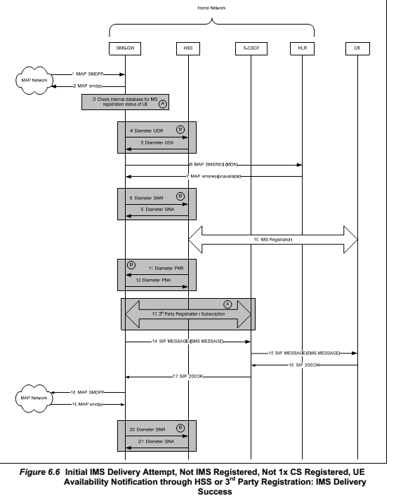

1. The SMS-GW for the UE receives a MAP SMDPP message for the UE from an originating SMS-GW. The originating SMS-GW is not shown for brevity.
2. The SMS-GW responds by sending a MAP smdpp message back to the originating SMS-GW.
3. Option A: If the SMS-GW receives IMS 3rdparty registrations or Registration Event notifications from the S-CSCF, then it checks its internal data base and determines that the UE is not IMS registered.

* Initial 1x CS Delivery Attempt: Success Scenario

Figure 6.8 illustrates a signaling flow for the scenario where an SMS message is delivered to a 1x CS registered UE.

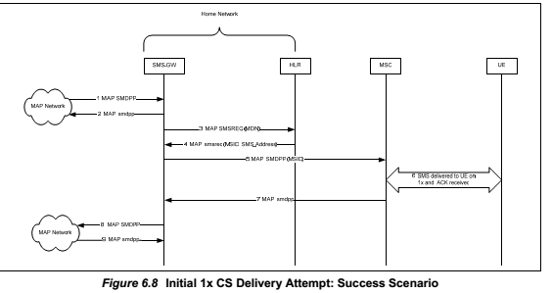

Preconditions:

 The SMS-GW is provisioned to prefer SMS delivery via 1x CS.

 The UE is 1x CS registered.

1. The SMS-GW for the UE receives a MAP SMDPP message for UE from an originating SMS-GW. The originating SMS-GW is not shown for brevity.
2. The SMS-GW responds by sending a MAP smdpp message back to the sender of the MAP SMDPP message.
3. The SMS-GW sends a MAP SMSREQ to the HLR containing the UE's MDN in
4. order to determine the UE's current routing information and retrieve the UE's MSID information. The SMS_NotificationIndicatorin the MAP SMSREQ is set to “Notify when available”.

* Initial 1x CS Delivery Attempt, Not 1x CS Registered: IMS Delivery Success

figure 6.9 illustrates a signaling flow for the scenario where the SMS-GWis configured for initial 1x CS delivery, but the terminal not 1x CS registered, so sends the SMS over IMS.

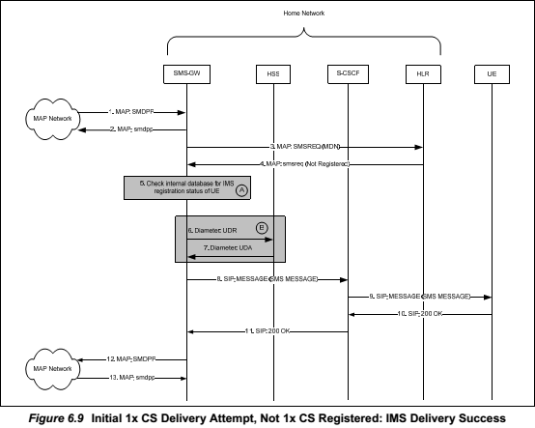

Preconditions:

 The SMS-GW is provisioned to prefer SMS delivery via 1x CS.

 The UE is not 1x CS registered.

 The UE is IMS registered.

1. The SMS-GW for the UE receives a MAP SMDPP message for the UE from an originating SMS-GW. The originating SMS-GW is not shown for brevity.
2. The SMS-GW responds by sending a MAP smdpp message back to the sender of the MAP SMDPP message.
3. The SMS-GW sends a MAP SMSREQ to the HLR containing the UE's MDN in order to determine the UE's current routing information and retrieve the UE's MSID information. The SMS_NotificationIndicatorin the MAP SMSREQ is set to “Notify when available”.

* Initial 1x CS Delivery Attempt, 1x CS Registered: IMS Delivery Success

Figure 6.10 illustrates a signaling flow for the scenario where a terminal that is registered in both IMS and 1x CS networks, fails to receive an SMS message on 1x CS, but receives it on IMS.

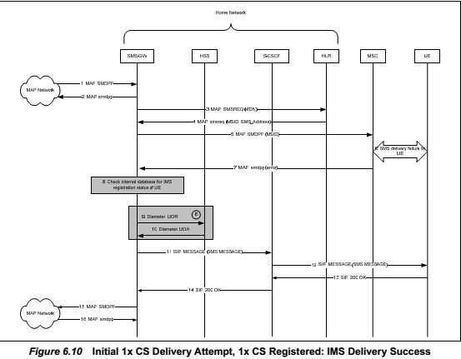

Preconditions:

 The SMS-GW is provisioned to prefer SMS delivery via 1x CS.

 The UE is 1x CS registered.

 The UE is IMS registered.

1. The SMS-GW for the UE receives a MAP SMDPP message for the UE from an originating SMS-GW. The originating SMS-GW is not shown for brevity.
2. The SMS-GW responds by sending a MAP smdpp message back to the sender of the MAP SMDPP message.
3. The SMS-GW sends a MAP SMSREQ to the HLR containing the UE's MDN in order to determine the UE's current routing information and retrieve the UE's MSID information. The SMS_NotificationIndicatorin the MAP SMSREQ is set to “Notify when available”.

* Initial IMS Delivery Attempt, IMS Registered, Not 1x CS Registered, 3rd party registration, SMS-GW retries

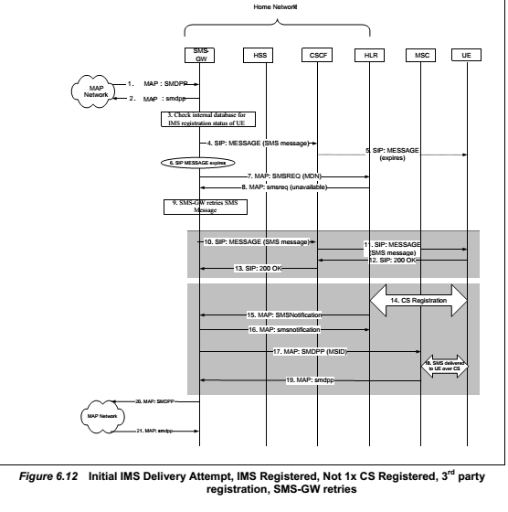

Preconditions:

 UE is IMS registered.

 UE is not 1x CS registered.

 SMS-GW receives 3rd party registration.

1. The SMS-GW for UE receives a MAP SMDPP message for UE from an originating SMS-GW. The originating SMS-GW is not shown for brevity.
2. The SMS-GW responds by sending a MAP smdpp message back to the originating SMS-GW.
3. The SMS-GW checks its internal databaseand determines that the UE is IMS registered.

* SMS Origination Procedures
* SMS Origination by UE that is IMS Registered

Figure 6.13 illustrates a signaling flow for the scenario where a terminal that is SIP registered and tuned to HRPD originates an SMS message. In this flow, it is assumed that the originating SMS-GW and the terminating SMS-GW communicate over the MAP network.

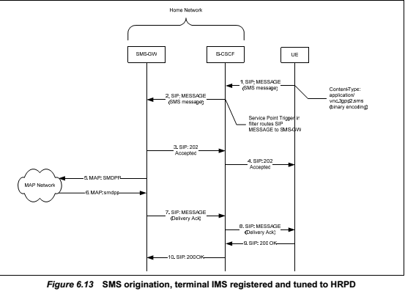

1. The originating UE formats an SMS text message using its SMS client software and sends the SMS text message in a SIP MESSAGE to another SMS user via the originating UE's P-CSCF and S-CSCF. The originating UE's P-CSCF is not shown for brevity. The originating UE inserts its tel URI in the From header and P-Preferred-ID header, and the tel URI of the SMS message receiver in the To header and Request URI. The Content-Type value associated with the SIP MESSAGE shall be "application/vnd.3gpp2.sms". The payload of the SIP MESSAGE shall contain a binary encoded SMS transport layer SMS Point-to-Point message [C.S0015].
2. The S-CSCF, based on the P-Asserted-Identity header and the filter Service Point Trigger, forwards the SIP MESSAGE tothe SMS-GW for the originating UE.
3. The SMS-GW responds by sending a SIP 202 Accepted to the S-CSCF.

* The SMS-GW responds by sending a SIP 202 Accepted to the S-CSCF.
* Inter SMS-GWs communication with subscriber address resolution

The MC functions are integrated into the SMS-GWs. Since the home networks of the SMS

message sender and the SMS message receiver are IMS networks, the SMS-GWs exchange the SMS messages over the core IP network. In this flow, the originating SMS-GW, upon accessing ENUM or a private database, obtains the SIP URI of the SMS message receiver (the UE), rather then the SIP URI of the terminating SMS-GW. In this flow, the originating network policies require that the originating SMS-GW routes the outgoing SIP MESSAGEs via the S-CSCF instead sending them directly to the I-CSCF in the destination IMS network.

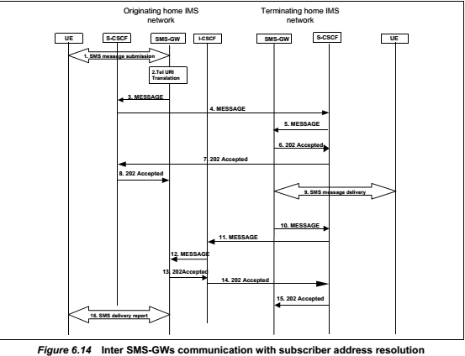

1. The SMS message sender sends a SIP MESSAGE with the SMS message in the body, and inserts its tel URI in the From header and P-Preferred-ID header, and the tel URI of the SMS message receiver in the To header and Request URI. The S-CSCF forwards the SIP MESSAGE, based on the originating iFC and the SMS body, to the originating SMS-GW.
2. The originating SMS-GW, using ENUM or a private database, translates the tel URI of the SMS message received into a SIP URI of the SMS message receiver (the UE), rather then the SIP URI of the terminating SMS-GW.
3. The originating SMS-GW constructs new SIP MESSAGE that contains the translated SIP URI in the Request URI, the tel URI of the SMS message sender in the From header, the SIP URI of the originating SMS-GW in the P-Asserted-Identity header, the tel URI of the SMS message receiver in the To header, and forward the SIP MESSAGE to the S-CSCF. In addition, the originating SMS-GW sets the Route header to the SIP URI of the S-CSCF and includes the "orig" in the Route header, and forward the SIP MESSAGE to the S-CSCF.

* Inter SMS-GWs communication withaddress resolution to SMS-GW

This flow assumes that the public ENUM does not contain the resource record for the user's E.164 number. Hence, the originating SMS-GW upon accessing eitherthe infrastructure ENUM or a private database obtains the SIP URI (i.e. the PSI) of the terminating SMS-GW (see [MMD Part-2]). In addition, the network policies in the originating IMS networks allow the originating SMS-GW to route the outgoing SIP MESSAGEs directly to the I-CSCF in the terminating IMS network

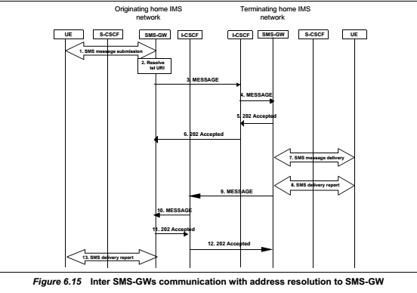

1. The SMS message sender sends a SIP MESSAGE with the SMS message in the body, and inserts its tel URI in the From header and P-Preferred-ID header, and the tel URI of the SMS message receiver in the To header and Request URI. The S-CSCF forwards the SIP MESSAGE based on the originating iFC and the SMS body to the originating SMS-GW.
2. The originating SMS-GW accessing the infrastructure ENUM or a private database and obtains the SIP URI of the terminating SMS-GW. Subsequently the originating SMS-GW resolves the SIP URI of the terminating SMS-GW (by the global DNS) to the I-CSCF address in the domain where the terminating SMS-GW is located (see [MMD Part-2] section 5.4.12.4).
3. The originating SMS-GW constructs new SIP MESSAGE that contains the SIP URI of the terminating SMS-GW in the Request URI, the tel URI of the SMS message sender in the From header, the SIP URI of the originating SMS-GW in the P-Asserted-Identity header, the tel URI of the SMS message receiver in the To header, and forward the SIP MESSAGE to the I-CSCF address obtained in step 2.

* *SIP Related Procedures*
* Introduction

void

* Functional entities
* User Equipment (UE)

UE dapat mengimplementasikann peran sms dengan IMS pada sender dana SMS dengan IMS pada receiver untuk pengeriman pada penerimaan SMS dengan IMS

* Application Server (AS)

AS dapat diemplementasikan pada peran SMS-GW

* Home Subscriber Server (HSS)

Pada registrasi UE,jika pelanggan telah memesan pelayanan SMS dengan IMS,maka HSS akan memasukkan di IFC dan mendownloadakan ke S-CSCF,SPTnya untuk mengarahkan Pesan SIP yang relevan ke SMS-GW.Pesan itu mengandung pesan registrasi,berasal dari Pesan SMS dengan IMS.

* Home Location Register (HLR)

Tidak ada prosedur khusus SMS dengan IMS pada HLR

* S-CSCF

Saat S-CSCF mengirimkan REGISTER SIP pihak 3 ke SMS-GW,S-CSF harus mengikuti prosedur yang sudah dijabarkan di [MMD Part-4].Selain itu,jikaHeader Timestamp dikirkmkan dari UE sebagai REGISTER SIP,S-CSCF harus memberi ijin secara transparan yang dimiliki REGISTER SIP ke SMS-GW.

* Roles
* SMS-over-IMS sender

1. General Procedures

Pengirim SMS dengan IMS harus mendukung prosedur yang berhubungan dengan UE secara tepat yang dijelaskan di MMD Part-4], Pengirim SMS dengan IMS harus mendukung prosedur yang dijelaskan di [C.S0015] untuk membuat Pesan Singkat

1. Registration

When the SMS-over-IMS sender registers with the IMS subsystem, the SMS-over-IMS

sender shall apply the procedures as specifiedin [MMD Part-4]. When constructing a SIP

REGISTER, the SMS-over-IMS sender shall include a Timestamp header [RFC 3261] in the SIP REGISTER. The value of the Timestamp headershall be set to the time, in seconds since January 1, 1900 00:00 UTC, at which the SMS-over-IMS sender generated the SIP

REGISTER

When the SMS-over-IMS sender regains IMS coverage, if the SMS-over-IMS sender had previously sent an SMS with a 1x CS-only status indication, the SMS-over-IMS sender shall send a SIP re-REGISTER over IMS to indicate to the SMS-GW that it has regained IMS coverage.

1. Submitting a short message

Ketika Pengirim SMS dengan IMS mau mensubmit pesan SMS dengan IMS,dia harus mengirim Pesan SIP dengan:

* The Request-URI shall be set to SIP URI or tel URI of the destination UE, or, if available, the SIP URI of the SMS-GW.
* the Request-Disposition header shall contain the "no-fork" directive
* the Content-Type header shall be set to "application/vnd.3gpp2.sms"

1. Processing an SMS Transport layer "SMS Acknowledge" message

Upon receiving a SIP MESSAGE with the Content-type header set to "application/vnd.3gpp2.sms", which contains an encapsulated "SMS Acknowledge" message, the SMS-over-IMS sender shall:

* generate a SIP response according to [RFC 3428]; and
* extract the SMS message from the SIP MESSAGE body and process the "SMS Acknowledge" message as defined in [C.S0015].

1. Processing of SMS “User Acknowledgement Message” or SMS “Delivery Acknowledgement MessageUpon receiving a SIP MESSAGE with a body of MIME type “application/vnd.3gpp2.sms” containing an SMS “User Acknowledgement” message or SMS “Delivery Acknowledgement” message, the SMS-over-IMS sender shall:

* generate a SIP response according to [RFC 3428];
* process the SMS Point-to-Point message received in the SIP MESSAGE as defined in [C.S0015].
* SMS-over-IMS receiver
* General Procedures

Penerima SMS dengan Ims harus mendukung prosedur yang terkait dengan UE dengan benar yang dijelaskan di [MMD Part-4].Penerima SMS dengan IMS harus mendukung prosedur yang dijelaskan di [C.S0015] untuk menerima SMS

* Registration

When the SMS-over-IMS receiver registers with the IMS subsystem, the SMS-over-IMS receiver shall apply the procedures as specified in [MMD Part-4]. When constructing a SIP REGISTER, the SMS-over-IMS receiver shall include a Timestamp header [RFC 3261] in the SIP REGISTER. The value of the Timestamp headershall be set to the time, in seconds since January 1, 1900 00:00 UTC, at which the SMS-over-IMS receiver generated the SIP REGISTER.

When the SMS-over-IMS receiver regains IMS coverage, if the SMS-over-IMS receiver had previously sent an SMS with a 1x CS-only status information, the SMS-over-IMS receiver shall send a SIP re-REGISTER over IMS to indicate to the SMS-GW that it has regained IMS

coverage.

* Receiving a short message

Upon receiving a SIP MESSAGE with the Content-type header set to

"application/vnd.3gpp2.sms", which contains anSMS “Deliver” message, the SMS-over-IMS receiver shall:

1. generate a SIP response according to [RFC 3428].
2. process the SMS Point-to-Point message received in the SIP MESSAGE as defined in [C.S0015].
3. if the SMS Transport Layer parameter "Bearer Reply Option" is included in the SMS message, the SMS-over-IMS receiver shall save the SIP URI of the SMS-GW and generate the SMS Transport layer "SMS Acknowledge" message as specified in section 7.3.2.4.

* “SMS Acknowledge Message” generation

When an SMS-over-IMS receiver wants to generate an SMS Transport layer "SMS Acknowledge" message over IMS, the SMS-over-IMS receiver shall send a SIP MESSAGE with the following information:

1. the Request-URI shall be set to the SIP URI of SMS-GW;
2. the Request-Disposition header shall contain the "no-fork" directive;

* the Content-Type header shall contain"application/vnd.3gpp2.sms"
* SMS-GW
* General

SMS-GW adalah suatu entitas yang menyimpan dan mengirim Pesan SMS ke dan dari SME dan diregitrasikan dari IMS dan/1xCS

* asas

1. BlackBox

Blackbox adalah suatu benda khayal yang mempresentasikan sistem dimana stimulus S masuk,dan timbul reaksi R akan muncul sebagai output.Konstitusi dan struktur kotak ini tidak relevant dalam ilmu ini ,dengan kata lain seseorang dapat melihat balckbox ini dalam suatu bidang eksternalanya atau secara *phenomenological,*hanya perilaku dari sistem yang diperhatikan.

Beberapa jenis stimulus dan respon dapat digambarkan sebagai *channels C* bersama *signals travel.*Suatu channel akan *assigned*  untuk setiap kelas stimulus atau respon,mengabaikan organ yang akan ikut campur atau mekanismenya Investigasiyangmenyangkut *nonphenomenoligical* atau theori yang bersangkutan.beberapa *gates* pada jenis yang sama tidak relefan dalam studi yang akan digunakan:

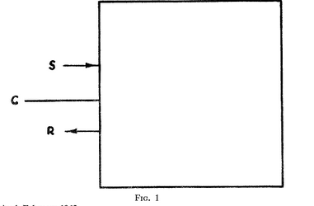

Teori blackbox: setiap jenis stimulus dan repon digambarkan sebagai jalur yang dikoneksikan antara kotaknya dengan lingkungannya. Hubungan antara masukan dengan keluaran diberi rumus yang bergantung dengan respon secara genral fungsi input secara nonlinier.Beberapa contoh: kotak transmisi sempurna,*the damping box,*dan kotak yang menguatkan.Teori ini merupakan pengembangan dari teori Matriks S,dan gambar jalur yang menemaninya di *microphsic* ,abstrak dan dapat diaplikasikan untuk etiap masalah yang melibatkan transaksi dari sistem(fisik,biologi,sosial,dsb) ,*superficial*,karena tidak meli batkan struktur alamai dari suatu stimulus dan responnya

Sumber: <http://www.jstor.org/discover/10empurna>,.2307/186066?uid=26879&uid=3738224&uid=2&uid=3&uid=26878&uid=67&uid=62&sid=21104953016517

1. RFT dan RPT

* RFT

RFT merupakan bagian dari QA yang mempunyai tugas untuk menguji fungsi dari suatu *webpage*

* RPT

RPT merupakan bagian dari QA yang mempunyai tugas untuk menguji performa dari suatu *webpage*

1. Sdsd
2. sdsd